**Scehdule Chart Box by Avishek**

Step 1:- Install node.js

Step 2:- install schedule-node

Npm install schedule-node

Step 3:- install socket.io

Npm install socket.io

Step 4:- Run the server

Step 5:- type localhost:3000 in your browser

Step 6:- Enter you username to join the chat

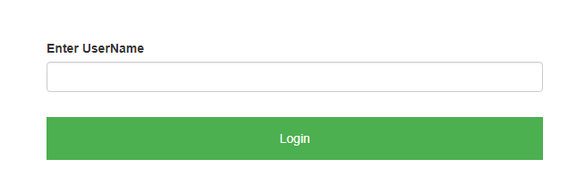

Step 7: enter message with timestamp to publish in future

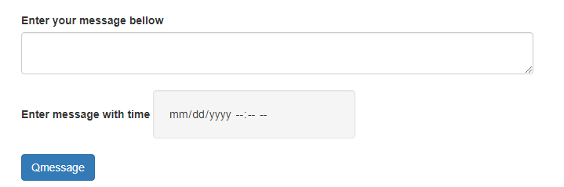

Step 8- For live chat don’t give any thing to time field.



Happy Chatting